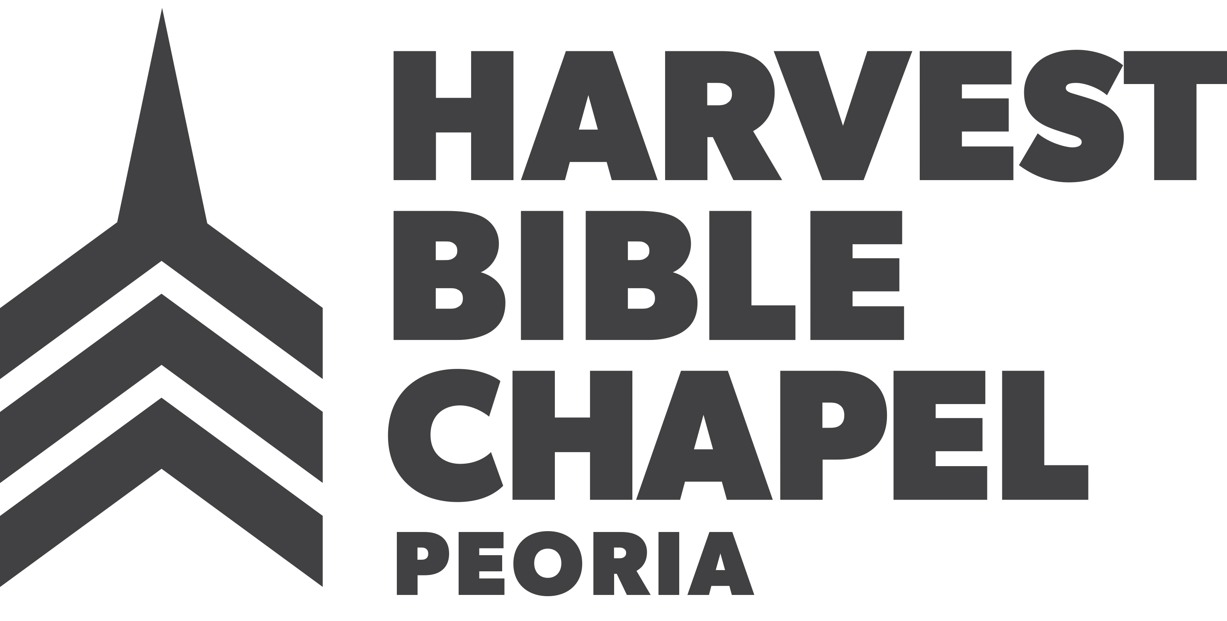

ALASKA IGNITE MISSIONS TRIP SUPPORT FORM

Check (√) which one(s) applies and send to:
Harvest Bible Chapel
401 CIMMERON DRIVE, EAST PEORIA, IL 61611

I will support ________________________
_____ PRAYERFULLY: With the Lord’s help, I will pray for you and the team on a daily basis.
_____ FINANCIALLY: $____________

Make your check payable to Harvest Bible Chapel. DO NOT place any note in the memo line of the check.
Your financial support needs to be sent to the church by
May 1, 2017 along with this support form. In the event that this person is unable to go on the trip, all money will be applied to the short-term missions program of the church. Thank you for your prayerful and/or financial support.

NAME:
ADDRESS:

PHONE:
As a 501(c)(3) non-profit organization, all contribution are tax deductible and you will receive a year-end receipt.

ALASKA IGNITE MISSIONS TRIP SUPPORT FORM

Check (√) which one(s) applies and send to:
Harvest Bible Chapel
401 CIMMERON DRIVE, EAST PEORIA, IL 61611

I will support ________________________
_____ PRAYERFULLY: With the Lord’s help, I will pray for you and the team on a daily basis.
_____ FINANCIALLY: $____________

Make your check payable to Harvest Bible Chapel. DO NOT place any note in the memo line of the check.
Your financial support needs to be sent to the church by
May 1, 2017 along with this support form. In the event that this person is unable to go on the trip, all money will be applied to the short-term missions program of the church. Thank you for your prayerful and/or financial support.

NAME:
ADDRESS:

PHONE:
As a 501(c)(3) non-profit organization, all contribution are tax deductible and you will receive a year-end receipt.

