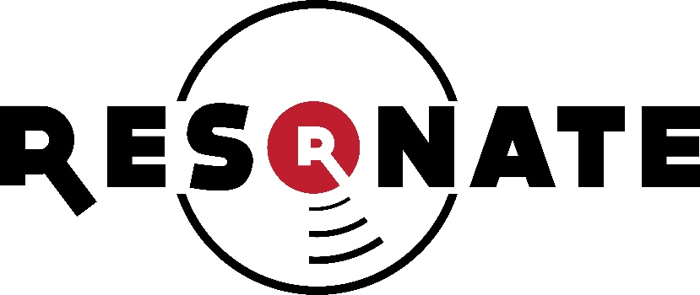
Harvest Bible Chapel Event Participation Form
Resonate Retreat
July 7th – 9th 2017

I understand the nature of the event and do hereby release Harvest Bible Chapel and its’ representatives from any liability due to accident or injury incurred.
I further agree to hold Harvest Bible Chapel and its’ representatives free and harmless of any claims, demands, or suits for damages arising from the authorization and provision of such medical treatment.

Signed: _______________________________________________________________________
Printed Name: _________________________________________________________________

Special Medications or Allergies: ___________________________________________________
______________________________________________________________________________
______________________________________________________________________________

Emergency Contact: ___________________________________ Phone: ______-_____-_______
Relationship to me: _____________________________________________________________

